**Ethereal – MYTH**

**MYTH description**

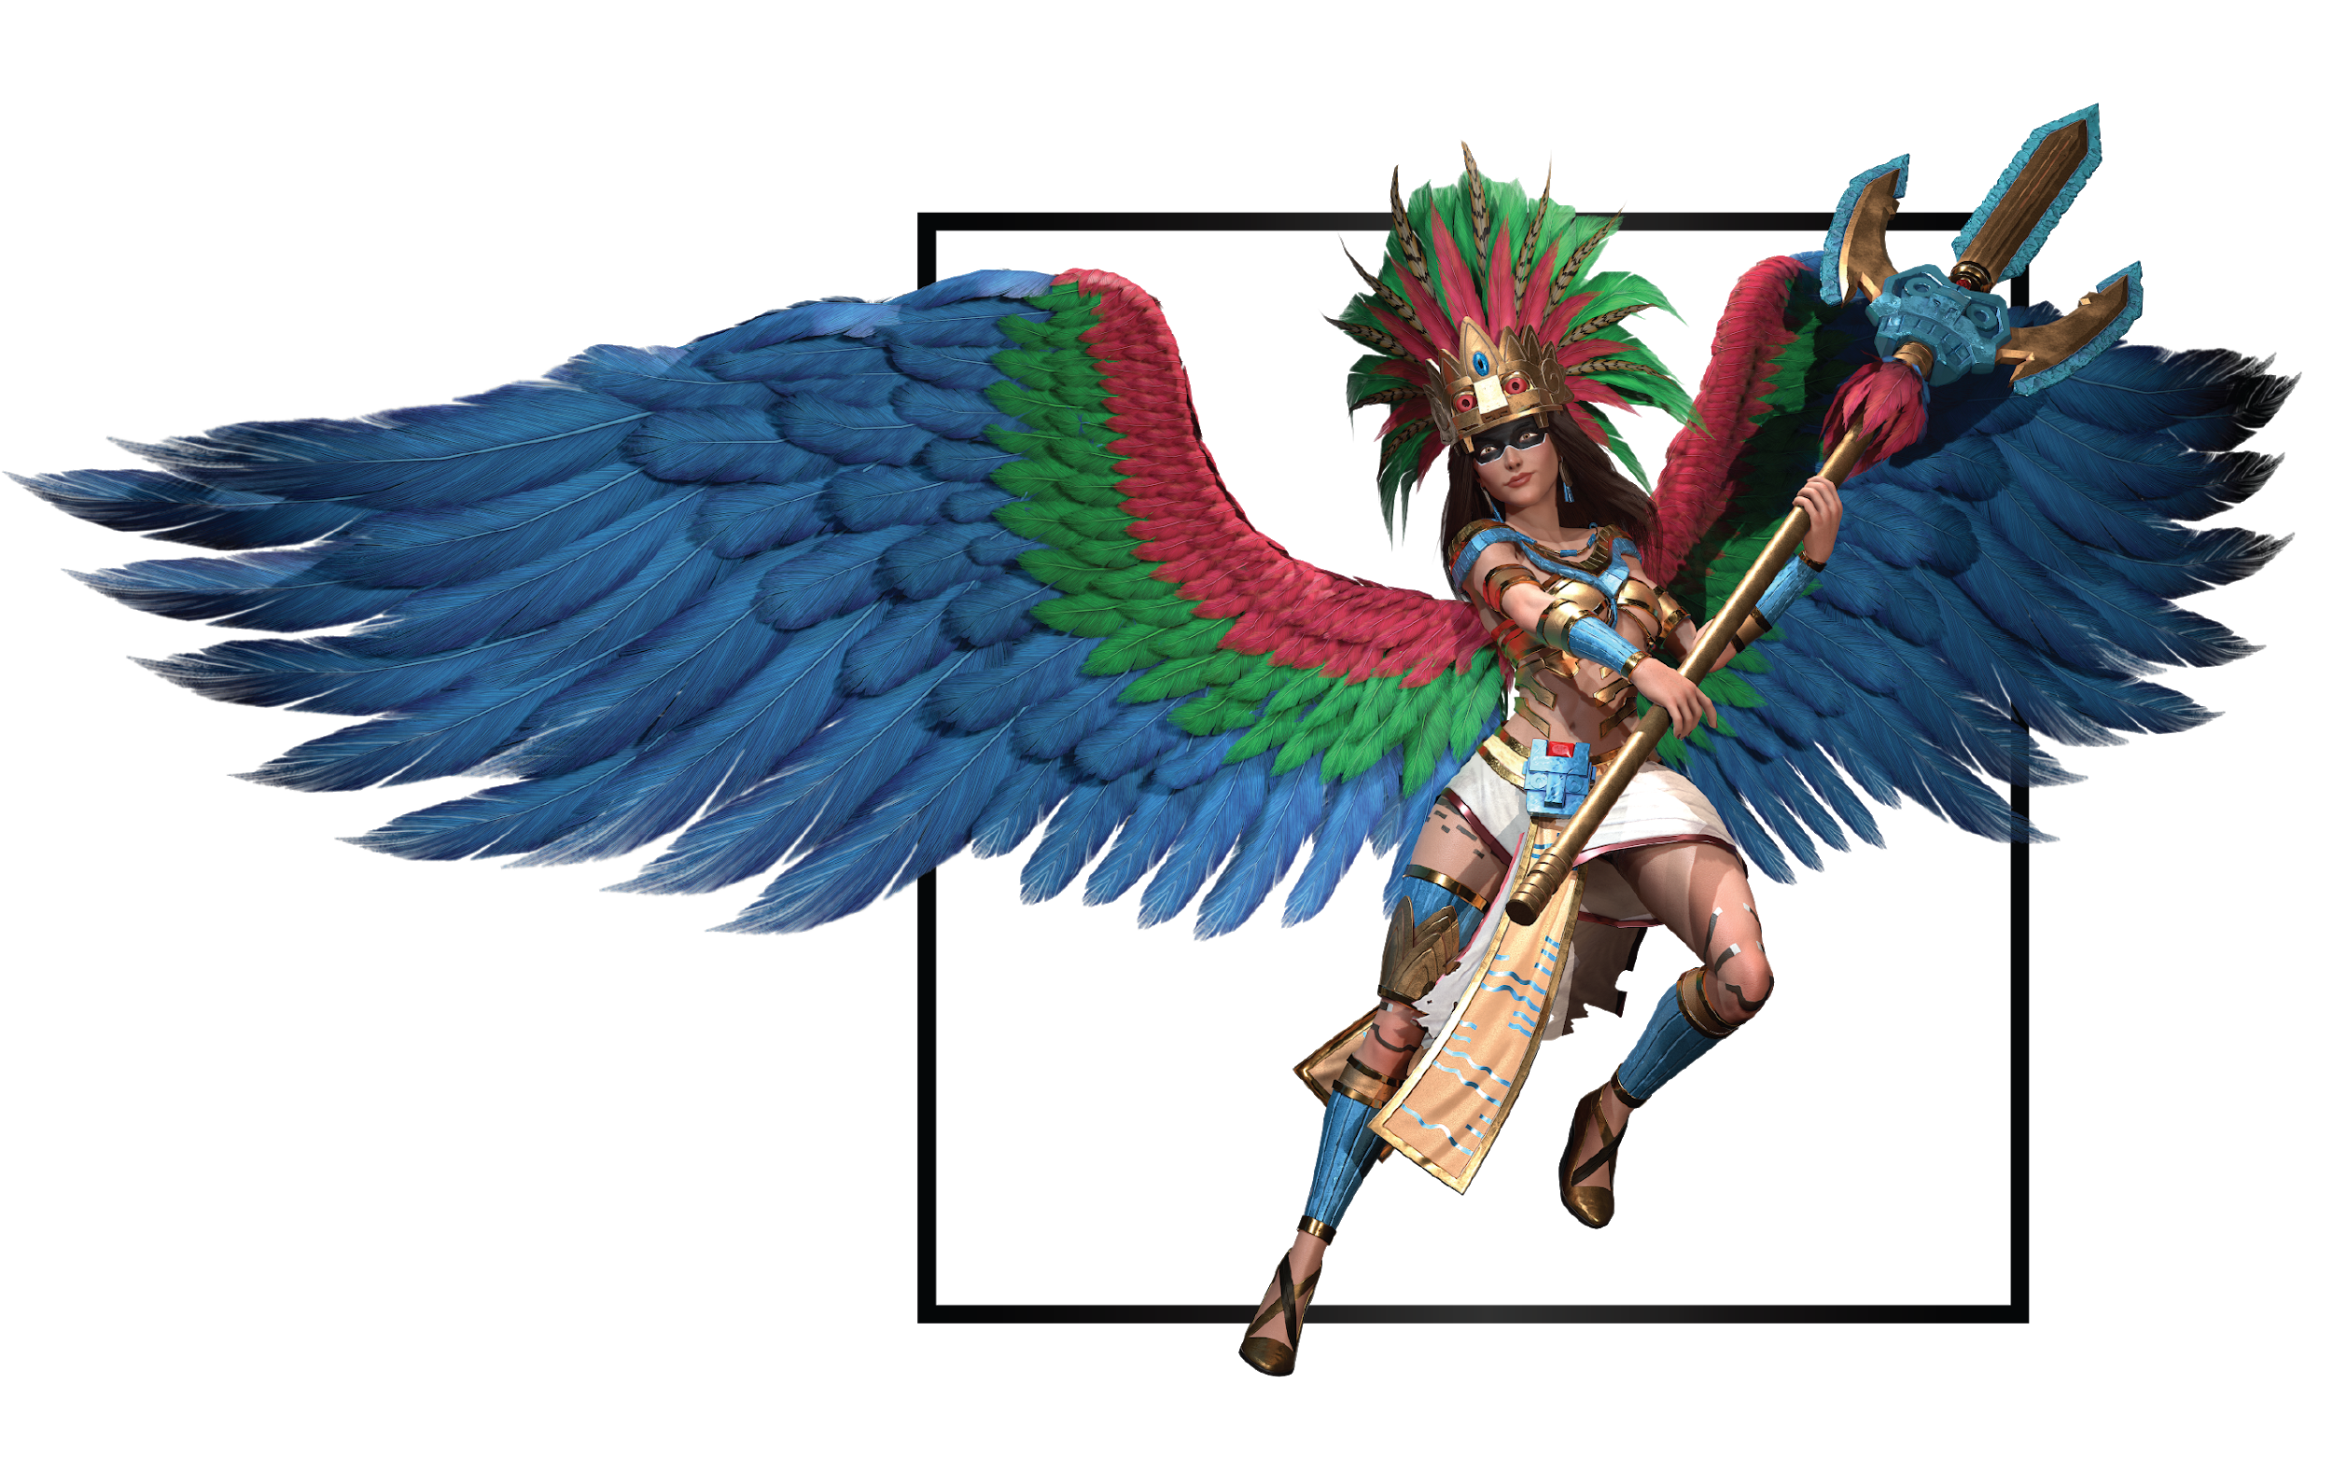

|  |  |
| --- | --- |
| **Name** | Lea |
| **Title** | Heir of the Jungle |
| **Realm** | Zuria |
| **Region** | Anghiera |
| **Class** | Sky Slayer |
| **Type** | Melee Magical |
| **Release Date** | Coming Soon |

Daughter of the sacred Yahimi tree, Inanis' gift to Anghiera, Lea sprung to life by prayers of people that needed a savior as the metropolis succumbed to internal violence and war. She was the last of the four descendants, their only hope.

Among whispers, the elders tell of a wingless Lea forced by her siblings to join their army, they sought glory and conquest for the rising Anghieran empire. Lea never wanted to use her powers for war, she didn’t want the same portrayal as the other mayhem-driven warriors.

In different murals of ruined temples, explorers found inscriptions that speak of Kauphi, a fearsome warrior in charge of chaining the wingless jungle descendant. He cornered her and pointed his legendary obsidian spear at the young woman’s heart. In a burst of light and wind, colored feathers enveloped Lea in a cocoon to protect her from the passage of time and the end of her civilization.

Lost in deep slumber, held by branches of an old ceibo tree, Lea laid wrapped inside the cocoon. A young boy lost into the depths of the jungle, one day found the ancient ruins of the first civilization.

When innocent hands graced the tree on the highest temple, the cocoon split open, feathers poured out and danced around the figure it held. A surge of energy knocked the boy away as the cocoon transformed into magnificent colorful wings. With dazzling light and wind that emanated from within her, Lea took to the skies and disappeared into a different Zuria.